Chapter 2
Digital and Analog I/O

Experiment 1 - Blinking LED 1
Experiment 2 - Turning On An LED 4
Experiment 3 - LED with Changing Blink Rate 4
Experiment 4 - Fading LED 5
Experiment 5 - Simple LED Control With a Button 8
Course Plan & Teachers 10

Link: https://www.electronicshub.org/getting-started-with-stm32f103c8t6-blue-pill/
Link: https://electropeak.com/learn/how-to-program-stm32-blue-pill-stm32f103c8t6-with-arduino-ide/
Link: https://stm32-base.org/assets/pdf/boards/original-schematic-STM32F103C8T6-Blue_Pill.pdf
Datasheet: https://www.st.com/resource/en/datasheet/stm32f103c8.pdf
Reference Manual: https://www.st.com/resource/en/reference_manual/rm0008-stm32f101xx-stm32f102xx-stm32f103xx-stm32f105xx-and-stm32f107xx-advanced-armbased-32bit-mcus-stmicroelectronics.pdf

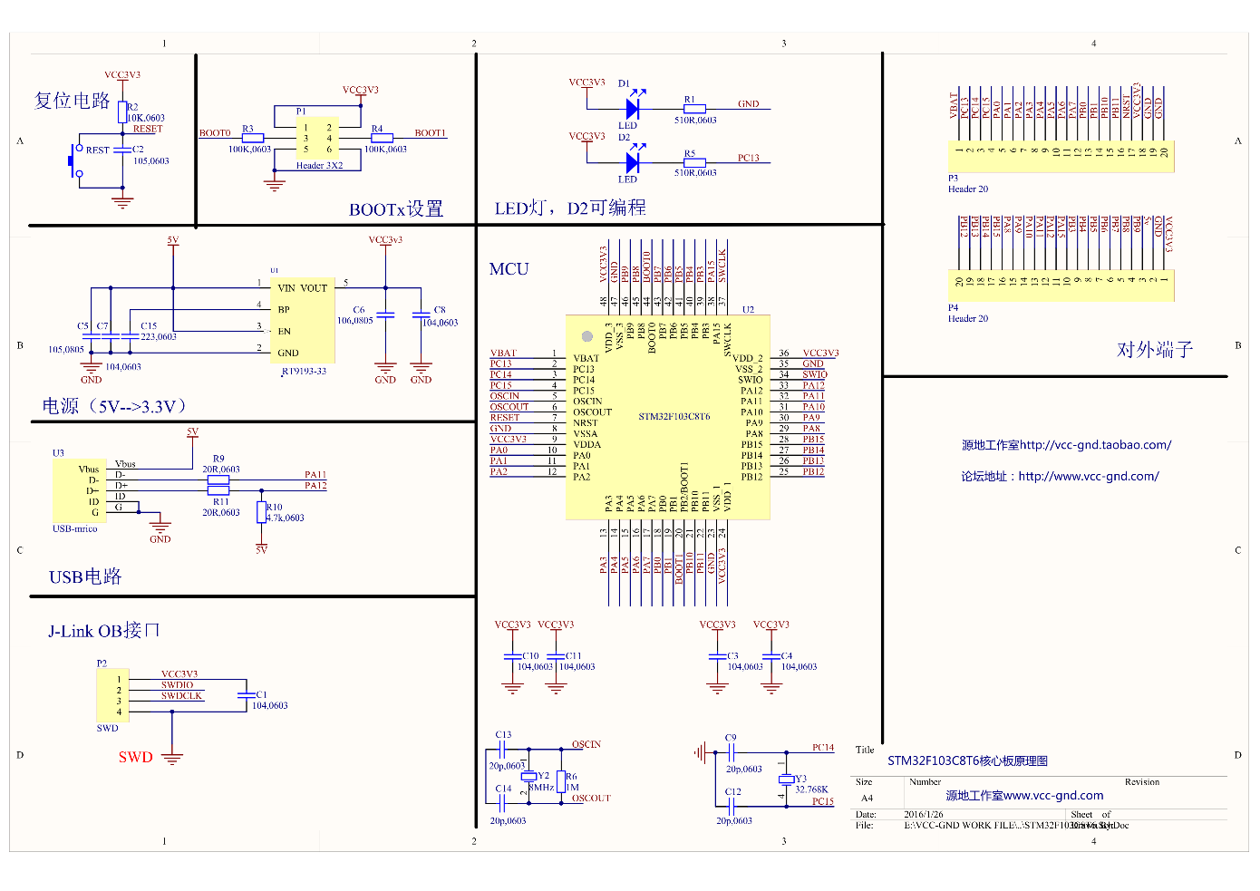

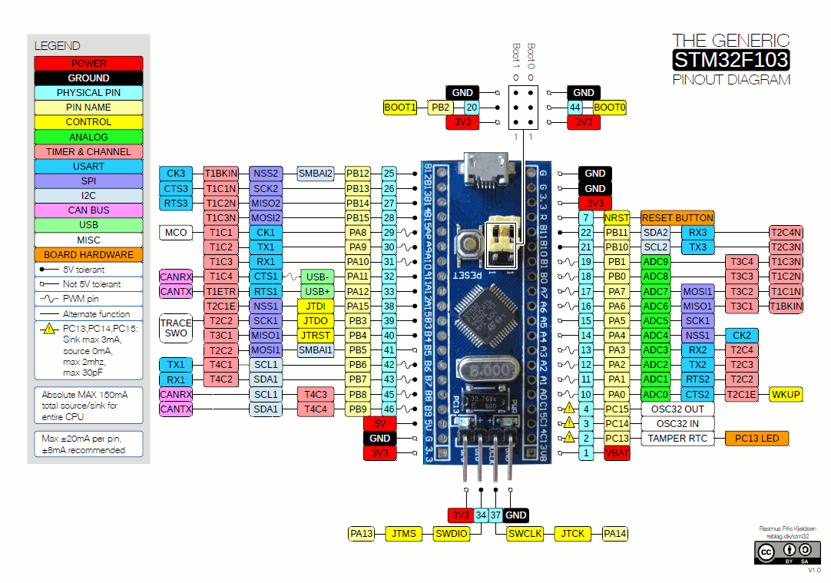

Experiment 1 - Blinking LED
void setup() {
// put your setup code here, to run once:
pinMode(PC13, OUTPUT);
}

void loop() {
// put your main code here, to run repeatedly:
digitalWrite(PC13, HIGH);
delay(1000);
digitalWrite(PC13, LOW);
delay(1000);
}

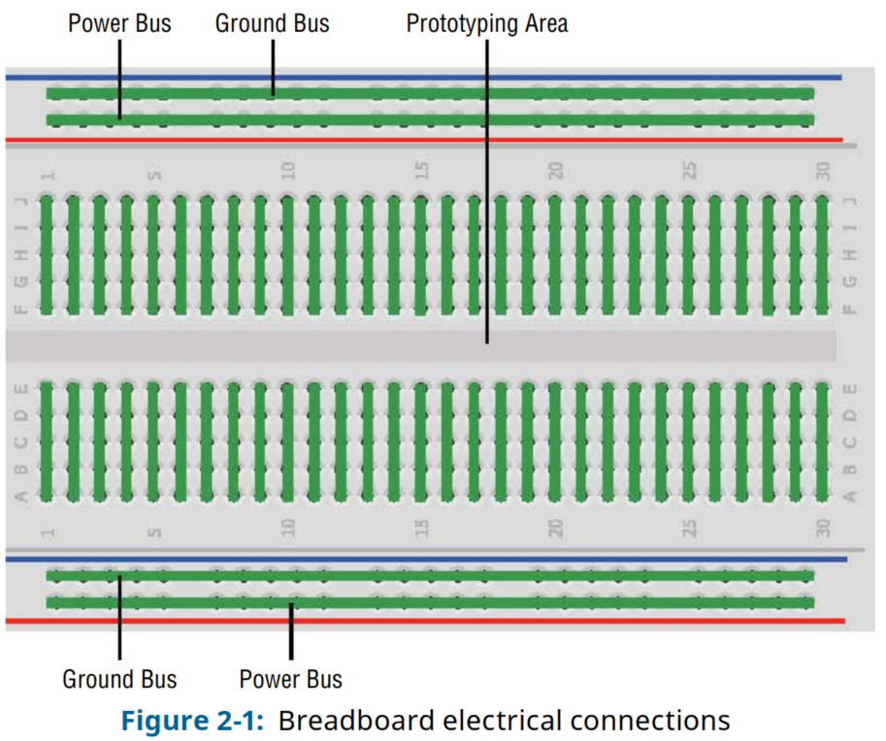
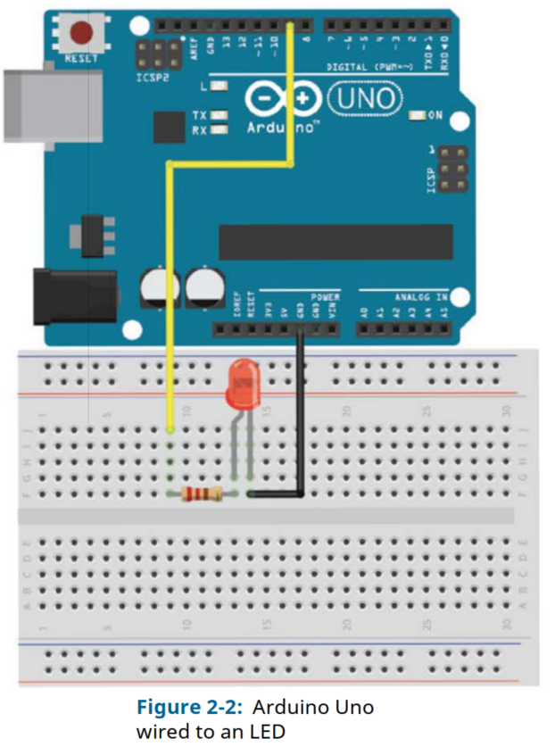

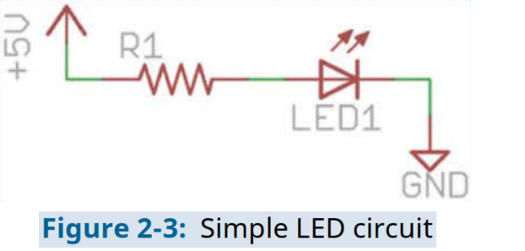
220Ω resistor
List of some of the digital output pins commonly used on the Blue Pill:
- PA0 - PA15 (Port A, Pins 0-15)
- PB0 - PB15 (Port B, Pins 0-15)
- PC13 - PC15 (Port C, Pins 13-15)

List of digital output pins available on the Arduino Uno:
- Digital Pins 0 to 13: These pins can be used as digital input or output pins. Digital Pins 0 and 1 are also connected to the hardware serial interface (RX and TX), respectively.
- Digital Pins A0 to A5: These pins can be used as digital input or output pins, in addition to their analog input functionality.

Experiment 2 - Turning On An LED
void setup()
{
pinMode (PA15, OUTPUT);
// Set the LED pin as an output
digitalWrite(PA15, HIGH);
// Set the LED pin high
}

void loop()
{
// We are not doing anything in the loop!
}

Experiment 3 - LED with Changing Blink Rate
void setup()
{
pinMode (PA15, OUTPUT);
// Set the LED pin as an output
}

void loop()
{
for (int i=100; i<=1000; i=i+100)
{
digitalWrite(PA15, HIGH);
delay(i);
digitalWrite(PA15, LOW);
delay(i);
}
}

Pulse-Width Modulation with analogWrite()
List of analog output (PWM) pins commonly used on the Blue Pill:
- PA0 (Timer2 Channel 1)
- PA1 (Timer2 Channel 2)
- PA2 (Timer2 Channel 3)
- PA3 (Timer2 Channel 4)
- PA6 (Timer3 Channel 1)
- PA7 (Timer3 Channel 2)
- PB0 (Timer3 Channel 3)
- PB1 (Timer3 Channel 4)
- PB6 (Timer4 Channel 1)
- PB7 (Timer4 Channel 2)

List of digital output pins available on the Arduino Uno:
- Digital Pins 3, 5, 6, 9, 10, and 11: These pins support PWM functionality and can be used for analog output via PWM.

Experiment 4 - Fading LED
void setup()
{
pinMode (PB0, OUTPUT);
//Set the LED pin as an output
}

void loop()
{
for (int i=0; i<256; i++)
{
analogWrite(PB0, i);
delay(10);
}
for (int i=255; i>=0; i--)
{
analogWrite(PB0, i);
delay(10);
}
}

Reading Digital Inputs
List of digital input pins commonly used on the Blue Pill:
- PA0 - PA15 (Port A, Pins 0-15)
- PB0 - PB15 (Port B, Pins 0-15)
- PC0 - PC15 (Port C, Pins 0-15)

List of digital input pins available on the Arduino Uno:
- Digital Pins 0 to 13: These pins can be used as digital input or output pins. Digital Pins 0 and 1 are also connected to the hardware serial interface (RX and TX), respectively.
- Digital Pins A0 to A5: These pins can be used as digital input or output pins, in addition to their analog input functionality.
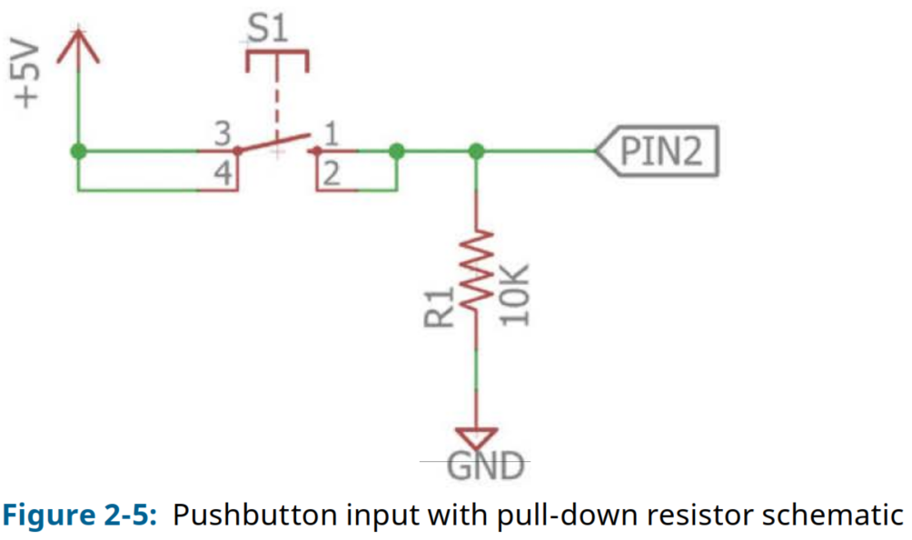
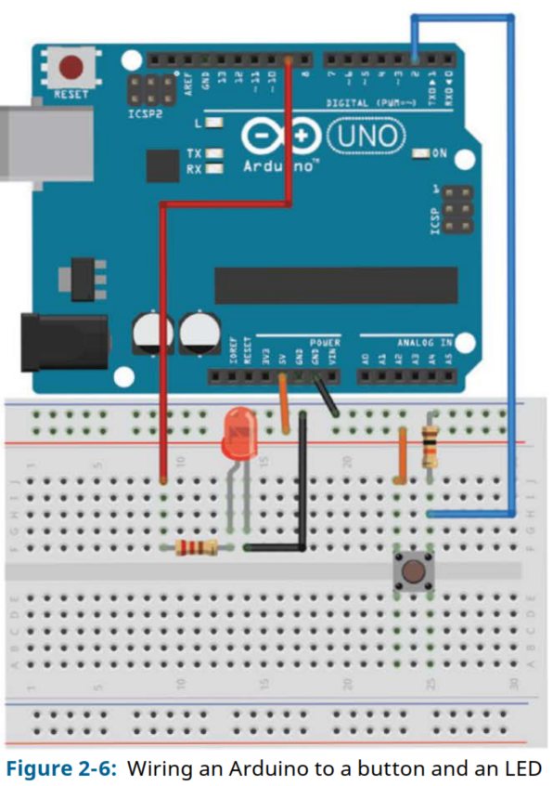

Experiment 5 - Simple LED Control With a Button
const int LED=PB0;
// The LED is connected to pin 9
const int BUTTON=PC15;
// The Button is connected to pin 2

void setup()
{
pinMode (LED, OUTPUT);
// Set the LED pin as an output
pinMode (BUTTON, INPUT);
// Set button as input (not required)
}

void loop()
{
if (digitalRead(BUTTON) == LOW)
{
digitalWrite(LED, LOW);
}
else
{
digitalWrite(LED, HIGH);
}
}

Experiment 6 - Reading temperature sensor
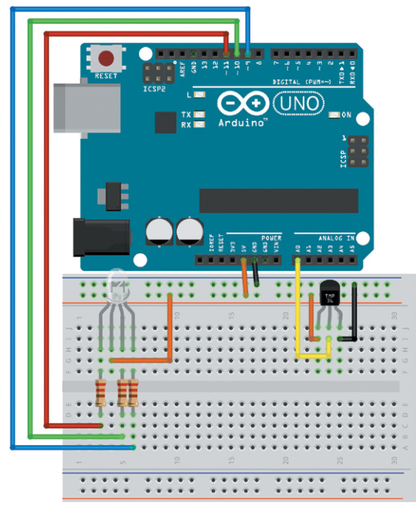

// Temperature Alert!
const int BLED=PB0; // Blue LED Cathode on Pin B0
const int GLED=PB1; // Green LED Cathode on Pin B1
const int RLED=PB2; // Red LED Cathode on Pin B2
const int TEMP=PA0; // Temp Sensor is on pin A0
const int LOWER_BOUND=139; // Lower Threshold
const int UPPER_BOUND=147; // Upper Threshold
int val = 0; // Variable to hold analog reading

void setup() {
pinMode (TEMP, INPUT);
pinMode (BLED, OUTPUT); // Set Blue LED as Output
pinMode (GLED, OUTPUT); // Set Green LED as Output
pinMode (RLED, OUTPUT); // Set Red LED as Output
}
void loop() {
val = analogRead(TEMP);
if (val < LOWER_BOUND) { // LED is Blue
digitalWrite(RLED, HIGH);
digitalWrite(GLED, HIGH);
digitalWrite(BLED, LOW);
}
else if (val > UPPER_BOUND) { // LED is Red
digitalWrite(RLED, LOW);
digitalWrite(GLED, HIGH);
digitalWrite(BLED, HIGH);
}
else { // LED is Green
digitalWrite(RLED, HIGH);
digitalWrite(GLED, LOW);
digitalWrite(BLED, HIGH);
}
}

Experiment 7 - Reading photoresistor

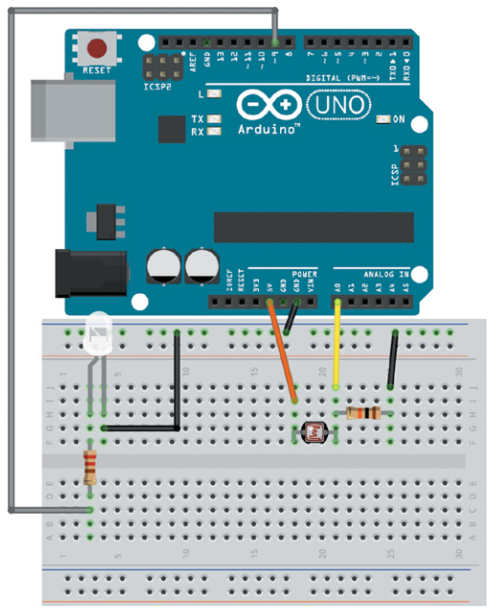
// Automatic Night Light
const int WLED=PA0; // White LED Anode on pin PA0 (PWM)
const int LIGHT=PA1; // Light Sensor on Analog Pin PA1
const int MIN_LIGHT=200; // Minimum Expected light value
const int MAX_LIGHT=900; // Maximum Expected Light value
int val = 0; // Variable to hold the analog reading

void setup() {
pinMode(WLED, OUTPUT); // Set White LED pin as output
}
void loop() {
val = analogRead(LIGHT); // Read the light sensor
val = map(val, MIN_LIGHT, MAX_LIGHT, 255, 0); // Map the light reading
val = constrain(val, 0, 255); // Constrain light value
analogWrite(WLED, val); // Control the White LED
}

Course Plan & Teachers
Nahin Ul Sadad, Assistant Professor, CSE, RUET
Md. Farhan Shakib, Lecturer, CSE, RUET
Md. Nasif Osman Khansur, Lecturer, CSE, RUET

